<Add Company Logo>

Last Update Date | <Last Update Date>
Owner | <Owner>
Status | <Status>

Corrective action procedures

Approval History

Version | Approved By | Approved On
1.0 | <Approver> | <Date of Approval>

Corrective Action Workflow

At <Company_Name>, the following workflow is in place for implementing preventive actions when nonconformity is found during audits or other reviews.
This document also provides details for recording, investigating, and addressing non-conformities.

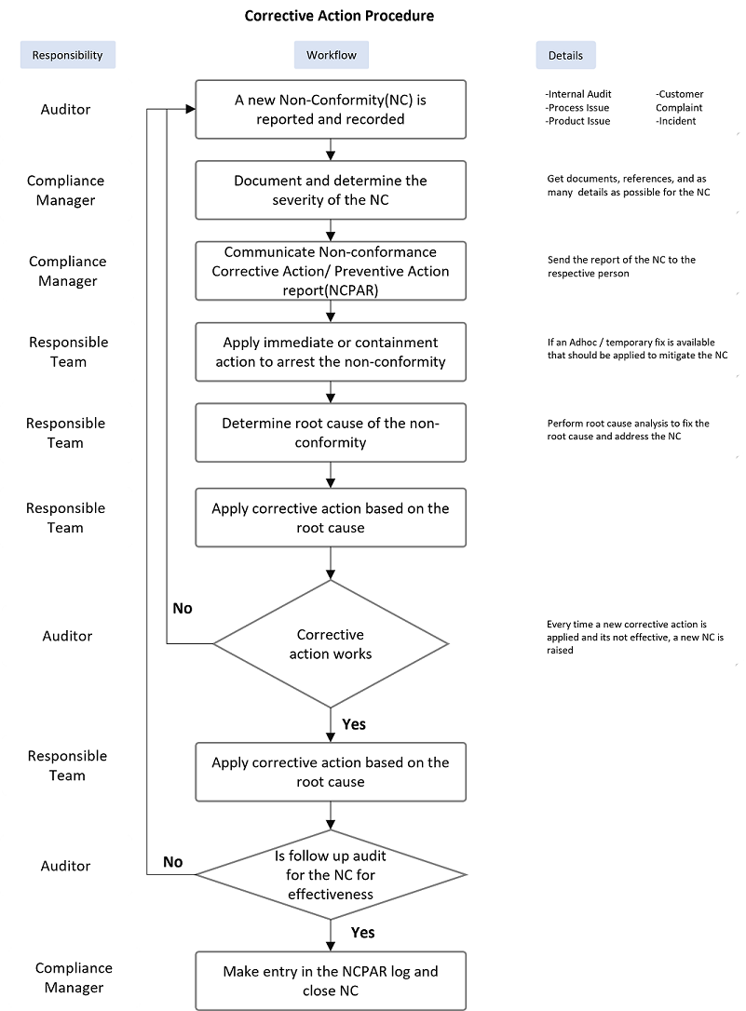

You can edit the diagram above here.

Sample Corrective Action Log
ID | Type of Non-Conformity (Audit, Review, Internal Audit etc) | Reported By | Date | Details (More details about the NC) | Immediate Action (Quick fix for NC) | Investigation (Root cause analysis) | References (Artifacts, tickets, links with more information about NC) | Implementation / Preventive Action (Final preventive action taken to address the NC) | Implementation Effective?  (Retest results)
The above log can also be maintained in individual documents for each reported Non-Conformity.

